Database System Engineering and Distributed Backend Development
Course Code: 25CS13002E
ROLL NO:2520030177
NAME: P.HARINI
AGGREGATE FUNCTIONS with WHERE, GROUP BY,
HAVING, ORDER BY

Query 1: Create A Data Base
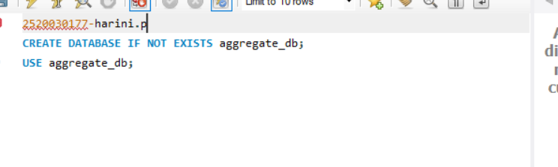
Output:

Query 2: CREATE TABLE
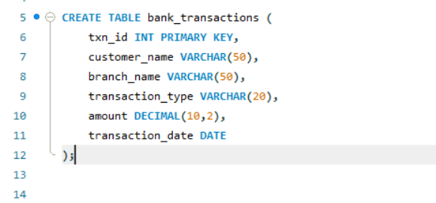
Output:
Query 3: INSERT DATA
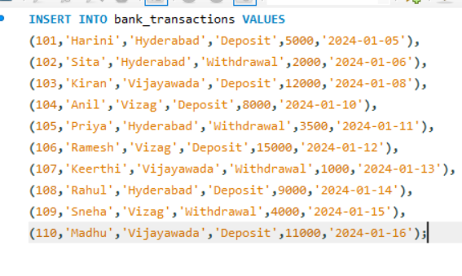
Output:

Query 4: SUM()
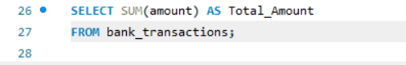
Output:
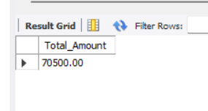

Query 5: AVG()
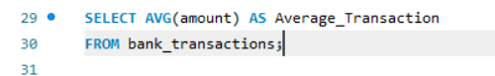

Output:
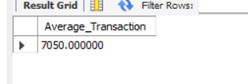

Query 6: MAX()
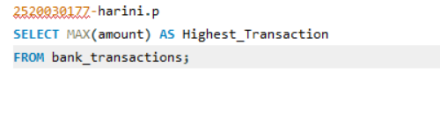
Output:
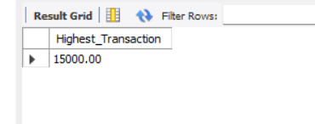

Query 7: MIN()
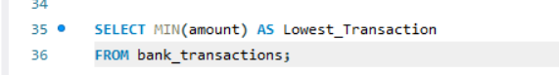
Output:
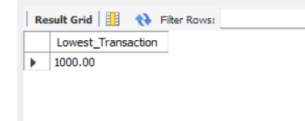

Query 8: COUNT()
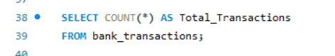
Output:
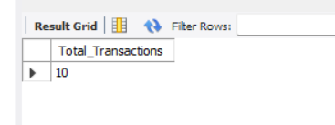

Query 9: WHERE + SUM()
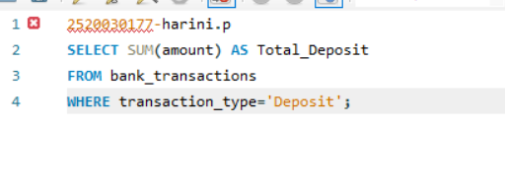
Output:
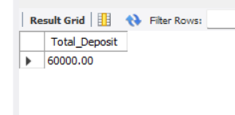

Query 10: GROUP BY
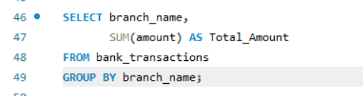
Output:
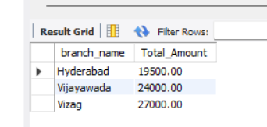

Query 11: GROUP BY + HAVING
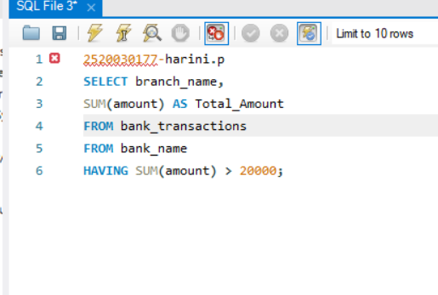
Output:
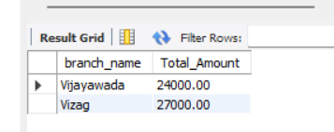

Query 12: GROUP BY + ORDER BY
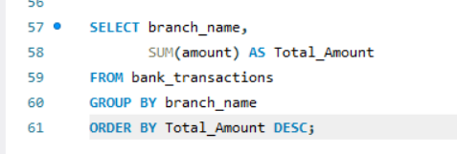

Output:
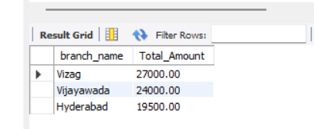

Query 13: GROUP BY + HAVING + ORDER BY
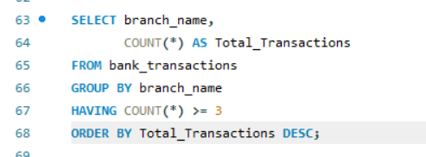
Output:
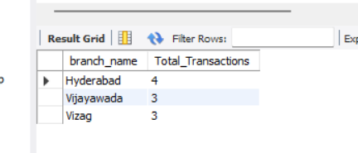

Query 14: WHERE + COUNT()
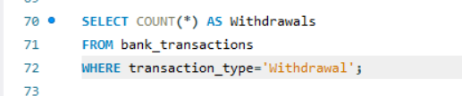
Output:
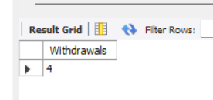

Query 15: WHERE + AVG()
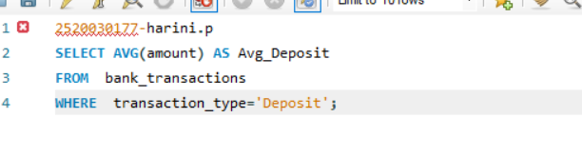
Output:
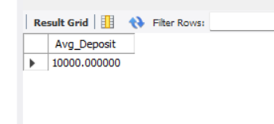

Query 16: GROUP BY + MAX()
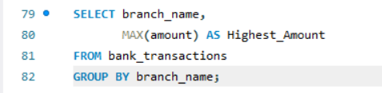

Output:
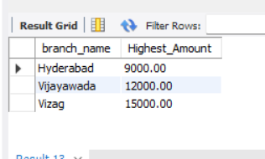

Query 17: GROUP BY + MIN()
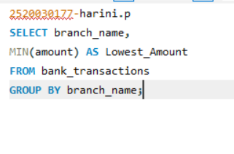
Output:
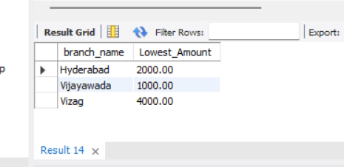

Query 18: WHERE + ORDER BY
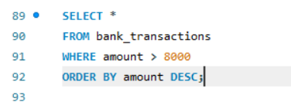

Output:
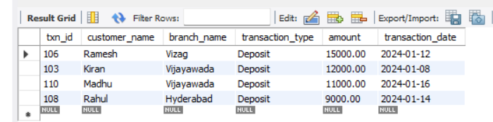

Query 19: GROUP BY + COUNT()
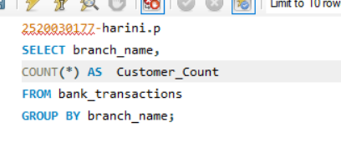
Output:
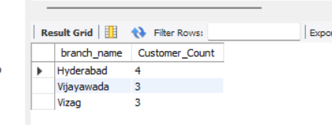

Query 20: HAVING + COUNT()
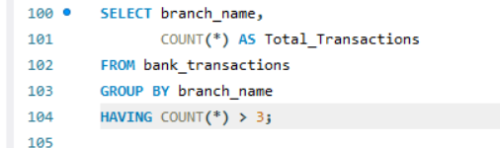
Output:
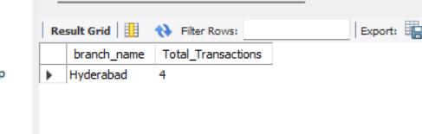

Query 21: GROUP BY + AVG()
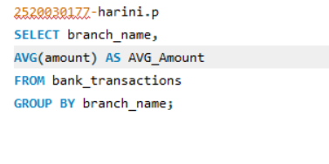
Output:
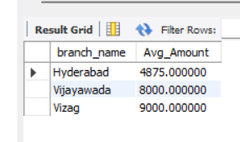

Query 22: WHERE + GROUP BY + HAVING
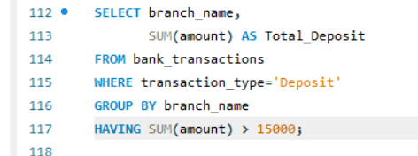

Output:
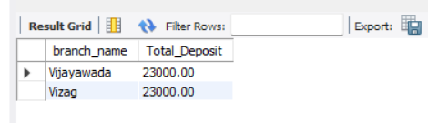

Query 23: GROUP BY + HAVING + ORDER BY
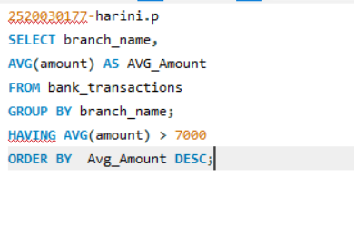
Output:
